render-cow Function

1. Signature, purpose, stub



1. Examples

+ velocity -> RCow: cow going to right

- velocity -> LCow: cow going to left

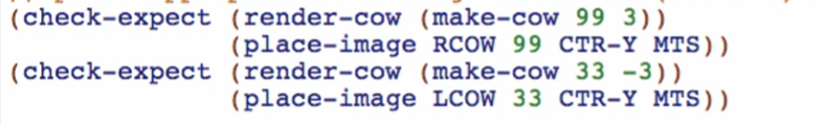

1. Templates

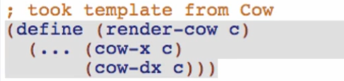

1. Code body

Working through the code body by using the examples

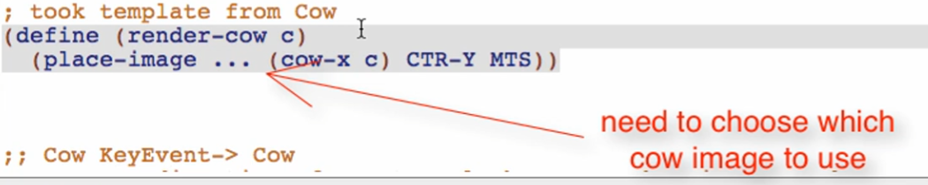

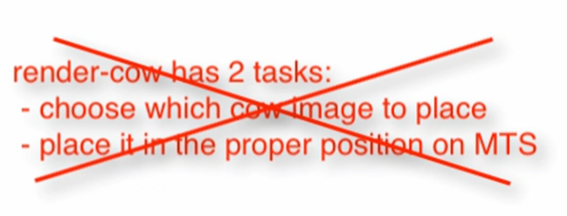

* We don’t want functions to do 2 tasks!

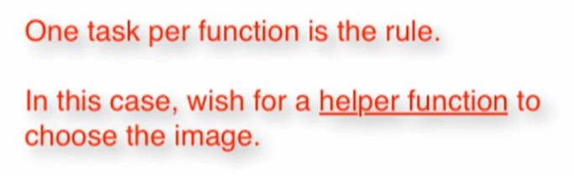

Wish for choose-image function



Write down the whole wish list (signature, purpose, stub, and !!!)

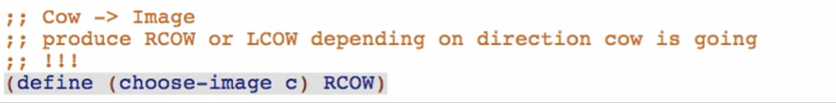

Check if well-formed

choose-image Function

1. Signature, purpose, stub (from wish list entry)

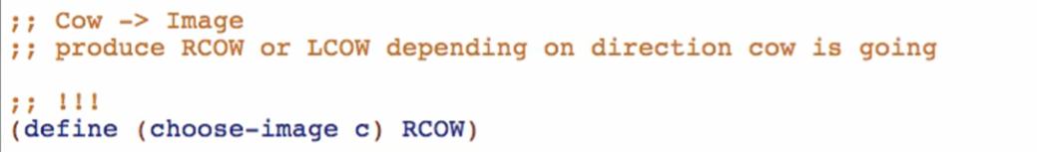

1. Examples

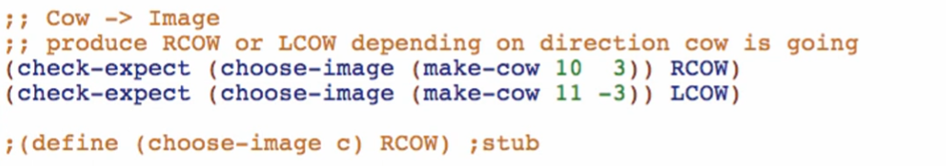

1. Template

Take template from Cow, rename function

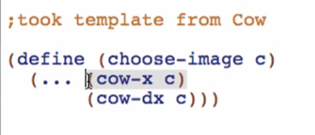

1. Code Body

2 cases: use if

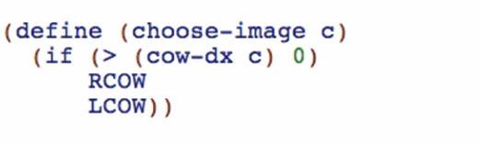

Modify examples and purpose to account for dx = 0

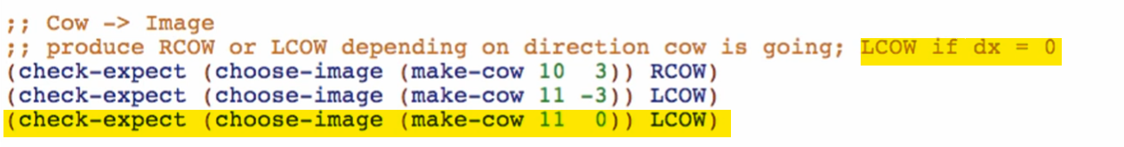

Overview:

